
CS 319
OBJECT-ORIENTED SOFTWARE ENGINEERING
Analysis Report
Dread of Evil Wizard
Group 20
Afra DÖMEKE
İlteber AYVACI
Tuğberk TOPALLAR
Utku OYMAK
Course Instructor: Uğur DOĞRUSÖZ

1. Introduction 3
2. Overview 3
2.1. Storyline 3
2.2. Character attributes 4
2.3. Status affects 4
2.4. Items and Inventory 5
2.5. Zones and Maps 6
2.6. Monsters 6
2.7. Classes & Skills 9
3. Requirement Specifications 10
3.1. Functional Requirements 10
3.2. Non-Functional Requirements 11
3.2.1. Usability 11
3.2.2. Reliability 11
3.2.3. Performance 12
3.2.4. Supportability 12
4. System Model 12
4.1. Use Case Model 12
4.1.1. View Credits 13
4.1.2. Play Game 14
4.1.3. Change Settings 15
4.1.4. View Help 16
4.1.6. Save Game 17
4.1.7. Load Game 17
4.1.8. View Own Statistics 18
4.2 Dynamic Models 19
4.3 Object Model 22
4.4 State Diagrams 25
5 User Interface 26
5.1 Screen Mock-ups 26
5.1.1 Main Menu 26

Introduction
We decided to develop and implement a game called Dread of Evil Wizard using java. It is a text based rpg game like the famous game Zork where users can control the character with written input through a text box. While the games input method is like zork, most of the rpg mechanics, fighting systems and skill systems are inspired by modern dungeons and dragons role playing games.

The game we influenced by is following.
https://www.youtube.com/watch?v=64-VQjygTGc
The main purpose of this game is to save the sister of our main character from the evil wizard by completing the missions and fighting the monsters. At the very beginning of the game, users will select their character, the difficulty level of the game and start to control the selected character by writing inputs through text box. In this respect, we plan to develop our game with 3 different choices and 4 different skills for each choice for the main character where users will be able to choose one and travel through 3 different zones during the game. In order to add visuals to our game, we decided to add maps showing the position and the movements of our character.
In addition to these, we are going to use features like an inventory bag that users can put the necessary items to improve our game.
This report contains an overview of the game, includes the storyline of the game and explains the elements and the rules of the game. Then it describes functional requirements, non-functional requirements and use-case’s model.

Overview

Storyline
Our main character (18 years old) and his little sister, Ariel (11 years old), lives in a little village called Ertoria. Since they lost their parents when they were very young, they have always been very close to each other. Even though they didn’t have parent, other villagers always helped them so they felt like whole village was their one big family.
Ertoria was a happy little village but things started to change when they started hearing the rumors of an evil wizard up in the north mountains. Villagers were concerned but they didn’t think something bad would happen to them since the evil wizard was so far away from their little safe heaven.
And then the unthinkable happened… Evil wizard and his unfathomably dreadful creatures came to Ertoria and slaughtered everybody. Last ones remaining was our main character and his little sister Ariel. They were hiding under the basement of their home but evil wizard found them too.
“Oooo… I have been looking for you for a very long time my little beauty!” – He said in his evil voice. Our main character fought with every bit of his strength but it was pointless. Evil wizard took his sister from his arms while leaving our hero heavily wounded on the dirt.
When our hero woke up he was in a shack with an old and mysterious man. He begged him so that he would teach him how to be strong. Old man was reluctant at first but he saw something in our hero’s eyes, a purpose, so he agreed.
Now our hero sets out to his journey to defeat the evil wizard and his unfathomably dreadful creatures and this is where our game starts.
Game will follow the main characters adventures through 3 different zones trying to reach the tower of the evil wizard and save his sister by defeating him.

Character attributes
There will be 4 different stats that a creature (the player, monsters and the boss) has in this game. Strength (str), dexterity (dex) , Intelligence (int) and constitution (const). These 4 attributes each affect a different thing in the character. Str is for determining the characters attack strength with physical attacks and the carry weight limit of the player, dex is for determining the characters speed, agility and characters stamina pool, intelligence is for determining the strength of magical attacks and the characters mana pool and constitution is for determining characters health pool.
When starting the game, player will be able to choose between 3 different classes and these different classes will have different base stats according to their play styles. After starting the game player will be able to increase one of these stats by 1 each time he levels up.

Status affects
Status affects are different harmful states that a character (this includes both the player and the monsters) can be in. They usually go on for 2-3 turns and disables the character in some way. There will be 5 different status affects in the game:
- Burning: Burning effect is inflicted by taking a large amount of fire damage from a source (source can be enemies or the environment). This affect lasts for 3 turns and character takes a set amount (exact amount will be decided in design stage for all of the status affects) of fire damage during these turns.
- Stun: One of the most devastating effects. This effect is inflicted by special attacks that have a chance to stun the enemy. Inflicted character is disabled for one turn (inflicted character basically loses a turn).
- Freeze: Freeze effect is inflicted by taking a large amount of cold damage from a source. This affect lasts for 3 turns and character is slowed down (gets a penalty to the dexterity stat) by a certain amount.
- Slow: Slow effect is inflicted by taking an average amount of cold damage from a source. This affect lasts for 2 turns and characters movement speed is reduced by a certain amount.
- Poisoned: Poisoned effect is inflicted by taking a large amount of poison damage from a source. This affect lasts for 3 turns and character takes a moderate amount of damage and slowed down by an amount (basically like a combination of burn and freeze affects but takes less damage than burning affect and slowed down less than the freeze affect).

Items and Inventory
Game will have 3 main types of items that can be taken by the player. All of these items will have differing weights. Player will have a weight limit on his inventory. Player will be carry a little bit more (exact amount not decided yet) than this weight limit but doing so will result in a “over encumbered” penalty which limits the players movement by a great amount. Being over encumbered will put the player in a major disadvantage in battles. (Player will not be able to run and it will be way harder to dodge incoming attacks) 3 Item types are:
- Wearables: These items are equitable by the player. Swords, daggers, armors etc. are all wearable. These items will be moderately heavy. This makes it so that player cannot run around with an armory on his back.
- Consumables: Consumables will be items like potions and food that are one time useable. Their weights will be low.
- Quest items: These items are requirements for finishing quests. For example, a villager wanted you to retrieve a necklace from the bandits. This necklace will be a quest item. All quest items weights will be minimum, 0.1 gram. This makes it so that player can finish a quest even when his inventory is full.

Zones and Maps
We decided to separate the world that game will take place in into 3 different zones. This is for the purpose of making game feel more linear (easier to understand what’s going on and know where to go). Every zone will be a n by n grid (we haven’t decided the scale yet since we will need to show these maps on the screen, We have to do some testing to see which number would suit it the best). Every cell in the grid will have a terrain type (grass, snow, stone, water) and every cell will be able to hold one object (characters, monsters, trees, buildings etc. are all counted as one distinct object.) at a time. If the object is something intractable (not a tree, rock etc. trees, rocks and rivers are going to be called terrain objects and they are not intractable, they just block the path basically) trying to move into the same cell will count as trigger for interaction.
There will be cells that has a monster on it. If the player tries to go into that cell, this will count as the initiation of the battle. Engaging in a battle will change the map that player is in. Map will turn into a battle arena. To better understand this, think of the every cell in the zone map as they are actually a big area like 50 meter by 50 meters in real life. Going into a monsters cell makes the map zoom in for engagement and that 50 meter by 50 meter plane becomes a n by n grid in itself. Another big thing is that even though player sees just one monster icon on the zone map, there could be actually more than one of that monster. Example case: Player sees an ogre on the zone map. Player engages in battle. In the battle arena map there are 3 ogres vs the player. (This makes it possible so that we can fit many different monsters into a n by n map without taking up too much space since every cell can hold only one object and makes the battles much more free and fun since both you and the monsters will be able to move around more freely)

Monsters
There will be 3 different species of monsters excluding the boss at the end of the game (evil wizard).

- Humans
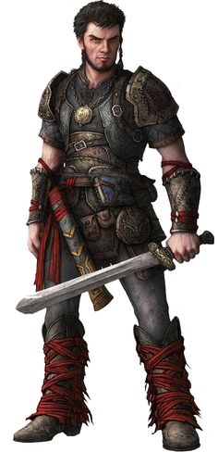 They are humans whose minds were warped by the evil wizard. They have 3 classes just like the player and they can do anything the player can.

- Ghouls
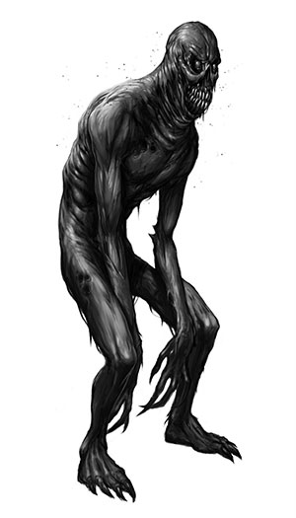
Ghouls are terrifying creatures that eat living flesh. They are undead who were resurrected by the evil wizard’s magic. Even though some of them live in the wilderness they are all bound by the evil wizard’s will. If he wants them to starve to dead, ghouls would starve to dead. They attack any living thing they see. They use their sharp claws and vicious bites to kill their victims. There are 2 different types of ghouls in the game:

  - Normal ghouls:
Normal ghouls use their claws as their main source of damage. Even though they are basically corpses that are reanimated through magic, they are stronger and faster than average humans. They also use their sharp teeth to bite chunks off their enemies flesh.
  - Poisonous ghouls:
Poisonous ghouls are normal ghouls that decayed for so long that their bodies became even more disgustingly rotten and started to produce poison. Their bites inflict a very strong poison to their victims.

- Ogres:
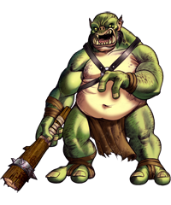
Ogres are big creatures that love to pound and eat their victims. They are less intelligent than an average human but since they tend to just eat the humans whenever they see one, their victims usually cannot find the time to trick the ogres. They are said to be the only monsters that actually cooks their victims before eating. There are also rumors that say ogres are better cooks than most humans. They use their mighty clubs as their main weapon. They can also use a breath attack to kill their enemies. There are 3 different types of ogres in the game:

  - Normal ogre:
Normal ogres uses their clubs and their breath to deal great physical damage to their enemies. Their breath attack has chance to stun their enemies making it easier to bash their victims heads in with their mighty clubs.
  - Fire ogre:
Fire ogres are usually shunned by their cousins. Reason behind this is because they usually “overcook” their victims. Their breaths can reach 1000 degrees Celsius. Even though they have the best taste between the 3 types of ogres, they don’t get the chance to show it because their victims get burned to crisp.
  - Ice ogre:
They are very similar to their normal cousins but the biggest difference is that their breath can freeze anybody who comes in contacts with it. Instead of pounding their enemies with clubs and cooking them on a grill, they like to freeze their enemies and then use the frozen pieces make delicious soups that bursts with flavor.

Classes & Skills
There will be 3 different classes user can chose from. They all have 4 unique skills they can use and all have different base stats that complements their play styles.

- Warrior
A strong melee fighter that charges head first into enemy lines. Has strong physical attacks and high health points. Uses stamina.
Skills
  - Chargee!! : Directly run towards the enemy and attack it with your whole body and momentum. Deals damage and stuns the enemy for 1 turn.
  - Ravage: Attacks the enemy 3 consecutive times. Deals massive damage.
  - Block: Blocks an incoming enemy attack.(Cannot attack the next turn)
  - Berserker’s blood: Warrior gives into his rage and goes berserk for 5 turns. Increases base strength and dexterity stats.

- Rogue
Cunning and fast, rogues uses their wits and clever tactics to defeat their enemies. Has high dexterity and uses stamina.
Skills
- Backstab: Run to the back of an enemy and backstab it. Deals big damage.
- Poison knife: Coat your weapon with poison. Attacks deal poison damage.
- Knife throw: Throws a knife at enemy far away. Deals damage.
- Invisibility: Turn invisibly for 3 turns. Enemies cannot attack you, you can move freely.

- Mage
Uses magic and elemental spells to defeat enemies. Low health points, high mana, very high damage potential.
Skills
- Fireball: Throw a fireball at an enemy. Deals great damage and burns the enemy.
- Ice spike: Creates and ice spike in air and throws it to the enemy. Deals damage and freezes enemy.
- Deflect: Use magical powers to reflect an incoming attack.(cannot attack in the next turn)
- Cosmic light: If this is used on an enemy, it deals massive damage. If used on self, character heals back to full hp.

Requirement Specifications

Functional Requirements
- User can create a unique character by changing the character’s class and stats.
- User can control the character with written input through the text box.
- Character can earn experience points by killing monsters and completing quests and level up.
- Player can increase his/her stats by leveling up.
- There are 3 different classes to choose from with 4 different skills each.
- User can unlock new skills by leveling up.
- Player character will be able to travel through different maps that are divided into grids.
- Player can fight with monsters on these map grids in a turn based combat.
- Game will be turn based.
- Player can save the game only at a specific location (a tavern in the city) on the map.
- Player can load the game from the save point.
- Player has an inventory that can hold various items.
- All the items has a weight.
- Player has a weight limit determined by characters stats.
- Player inventory can NOT hold more weight that the player’s weight limit.
- When player dies, all of that characters save files are deleted.(Hardcore game)
- There will be a background music.
- Game will have 4 species of monsters, some monsters will have different types.(Undead, Ogre, Human, Evil wizard)(Ogres: Ice ogre, fire ogre, poison ogre)
- There will be a final boss to end the main storyline.
- Monsters will have stats like the player character.
- Battle sequences and outcomes will be decided according to these stats.
- There will be 2 difficulty level, easy and hard.
- Difficulty level will change the monsters stats.
- There will be 3 different types of maps (Snow map, stone map, forest map)
- Different types of terrain will have different effects on the character.

Non-Functional Requirements

Usability
Any user who can understand English will be able to play the game since the inputs and outputs are in plain English. Help page consists the required information about the dynamics of the game (e.g. power and attack type differences for unique characters, creatures user may interact, information about level-up and stat system, rules regarding load/save etc.) to inform and familiarize with the world created for the game. The grid-map system will make help the user’s orientation in the map(s).

Reliability
The inputs which user can enter are limited to some extent. If the game is expecting a navigation command from the user like “GO NORTH”, typing “ATTACK” would not be accepted even though “ATTACK” may be a valid command for the game. The inputs outside the valid commands are ignored by default thus an error caused by input is avoided. Also this game does not require any hardware like special purpose keypad or controller so as long as the PC which will be played on is robust so does the game. In the event of unexpected data loss (e.g. save/load functions of the game) the game should be still operational since the deletion of the saved data is already a function of the game if user dies.

Performance
The reaction time for user input is at most 3 seconds (calculations and rendering combined). Hence the game is turn based the maximum throughput is one command at a time both from the computer and the user.

Supportability
Story line, map, characters, items can be expanded later on as updates.

  - Constraints (“Pseudo requirements”)

- Implementation requirements
All of the Dread of the Evil Wizard will be developed using Java.
- Interface requirements
Every OS supporting Java should be able to run the game.

System Model

Use Case Model
This section provides information about the main use case model of Dread of Evil Wizard game, detailed use case explanations are included below.
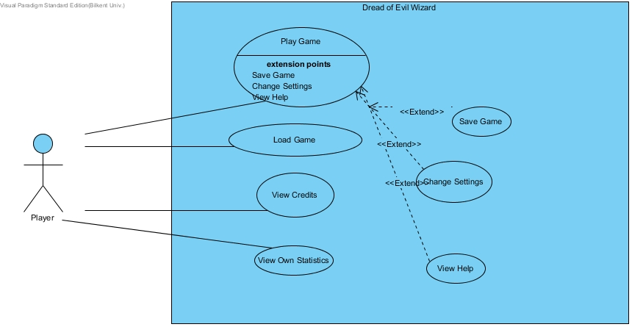

Figure 4.1 – Illustrates the use case model of Dread of Evil Wizard

View Credits

Use Case Name: View Credits
Primary Actor: Player
Entry Condition: Player wants to see the credit AND player inserts appropriate command to the textbox
Flow of Events:
1. Player inserts the appropriate message to the text box while he/she is on the game.
2.Credits are shown to the player by System.
Alternative Flow of Events:
1.A – Player finishes the game successfully
System automatically shows the credits to the player
Exit Condition: Player displays the Credits.

Play Game

Use Case Name: Play Game
Participating Actor: Player
Entry condition: Player opened the game AND
Player inserted appropriate command to the system to play the game.
Exit condition: Player inserts the appropriate command to quit the game OR
Player dies and there is no saved progress OR
Main Flow of Events:
1. The system shows possible selections the player can do.
2. Player selects playing the game
3.System displays 3 classes that player can select.
4.Player selects one of the given classes.
5.System displays 2 difficulty levels he/she can select.
6.Player selects a difficulty level.
7. System starts the new game by displaying a map which has the environmental objects, monsters, Nonplayable Characters and Player with his/her position on the map.
8.System displays a tutorial guide that has information about what the player should do at the beginning of the game.
9.System gives an automatic tutorial quest to the Player.
10. Player completes the quest by going to the nearest Non-Playable Character and talking with him, killing a monster with using his/her skills that are unlocked at the beginning.
11. Player receives an item as a quest reward.
12. Player opens the Inventory page by inserting appropriate message to the text box and Player uses the item that is given to him/her.
13. Player does the main quest which has a purpose of saving Player's sister.
14. Player gains Experience Points by killing monsters and doing other side Quests while main quest is still active.
15. Player's level increases by one after he/she collects certain amount of Experience Points.
16. System unlocks a new skill on each new level.
17. Player fulfills the requirements of the main quest by killing monsters and talking to several Non-Playable Characters.
18. Player completes main quest by killing the final boss.
19. System displays the Credits.
20. System displays the possible selections the player can do after the Credits.
Exit Conditions: Player should complete main quest OR
Player should die OR
Player should manually input appropriate command to quit the game.
Alternative Flows:
2A. Player has a saved progress.
2A.1. The system tries to find the saved progress on HDD.
2A.2. After system validates that the chosen file is a valid save game data, System loads the saved progress
2A.3 Player continues after where he/she left previously.

A. Player wants to quit at any time during the game:
A.1. Player enters the command to quit the system
A.2. System gives a warning message to inform Player's unsaved content will be lost when Player quits the game

A.2. System verifies that Player approves the message.
A.3. System takes the Player back to desktop.

Change Settings
Use Case Name: Change Settings
Primary Actor: Player
Entry Condition: Player wants to change of the game AND Player asks the system to see how can he change settings.
Flow of Events:
1. Player asks the system to change settings.
2. Current Game settings are shown to the player by System along with text-based message that contains information about how to change settings.
3. Player sets the settings to whatever he wants.
4. System applies new settings to the game dynamics.
5.Player returns to the game.
Alternative Flows:
3.A – Player wants to change settings to the default settings.
System applies default settings to the game dynamics.

Participating actors
  - Describe the entry condition
  - Describe the flow of events
  - Describe the exit condition
  - Describe exceptions
  - Describe nonfunctional requirements
Exit Condition: Player returns back to the game

View Help

Use Case Name: View Help
Participating Actors: Player
Entry Condition: Player wants to learn about FAQ about game AND Player ask the system to view help.
Flow of Events:
1.Player asks to view help.
2. System displays the help guide which contains information about game dynamics,monsters,quests that is prepared by developer team
Exit Condition: Player quits the guide and returns to the game.
Exception: None
NonFunctional Requirements: Player should download the game version that includes Help File.

4.1.6. Save Game
Use Case Name: Save Game
Primary Actor: Player
Entry Condition: Player wants to save his gaming progress and asks the system to save his/her progress
Flow of Events:
1. Player asks the game to save game.
2. System saves the game by saving Player’s progress into HDD.
3.System shows appropriate message to inform Player about success of saving the game
Exception:
2.A – System fails to save the progress of the Player due to insufficient space on HDD
System informs the player with a failure message.
Alternative Flows:
2.A – Player has a previously saved game.
2.A.1System asks the user about whether he/she wants to overwrite the save or not.
2.A.2.System overwrites the save game if player approves, System does not overwrites the save file if player refuses.
Exit Condition: Player is informed by appropriate success message after his/her attempt to save gane.

4.1.7. Load Game

Use Case Name: Load Game
Primary Actor: Player
Entry Condition: Player wants to save his gaming progress and asks the system to save his/her progress
Flow of Events:
- Player selects loading game option.
- Player finds the save file he/she wants from the HDD.
- System checks to see if the chosen file is a valid save data file.
- System loads all the previously saved settings
- Player plays from where he/she left previously.
Exception:
1.A.1 – Player is dead
1.A.2 – Game is loaded from previously saved game. If there is no save file, then Player starts from the beginning.
2.A.1 – System cannot find the save file on HDD
2.A.2– User is informed that there is no previously saved progress
2.A.3 – Player returns to the state where he can select options including creating a new game, changing setting etc.

4.1.8. View Own Statistics
Use Case Name: View Own Statistics
Primary Actor: Player
Entry Condition: Player wants to view his/her progress on the game.
Exit Condition: Player returns back to the game.
Flow of events:
- Player asks the game to view his/her statistics.
- The System collects information about Player's completed Quests, killed monsters, Collected items.
- System displays a message that contains Player's completion in terms of quests collected, monsters killed and items collected by player over total amount.
- Player returns back to the game
Exit Condition: Player returns back to the game.

4.2 Dynamic Models
4.2.1 Sequence diagrams
4.2.1.1 View Credits
Scenario: In an already started game session it is Player Cengiz’s turn and player enters the “View Credits” command to see the game credits. Credits displayed on the console after Player is done reading the credits Player enters “Return Game” command to return the actual gameplay.

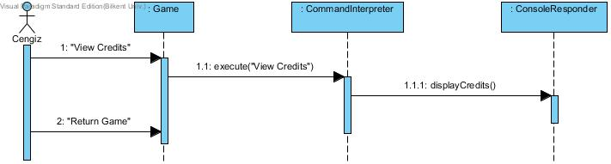
Figure 4.2.1: Sequence Diagram For View Credits

4.2.1.2 Play game
Scenario: Assumed player Cengiz already set up the character as a Rogue called Terminator and familiar with the dynamics of the game. In this game session Cengiz sees the one box above the character currently occupies is not empty, to interact with that map location Player types “Go North” this results in Terminator interacting with another character (a NPC) in the game. NPC reveals a quest to Cengiz in the console. The quest is battling an enemy to the death in the north and be victorious! Cengiz enters “Go West” since he has to travel around the NPC and continues to travel to the north by typing “Go North” until an encounter with the Damned Ghoul. After this encounter the battle map is activated. Player types “Backstab” to attack the Ghoul, console prints “Attack Successful!” now the turn is Ghoul’s, console prints “Ghoul has bitten you!” now Cengiz must make his move he types “Poison Knife” resulting in 1 poison potion destructed from user’s inventory as cost of this attack and console prints “Attack successful!” following “Damned Ghoul is slaughtered” at this point Terminator is rewarded with the quest item and now needs to continue to roam the map to find the new quest to lead him to the other victories!
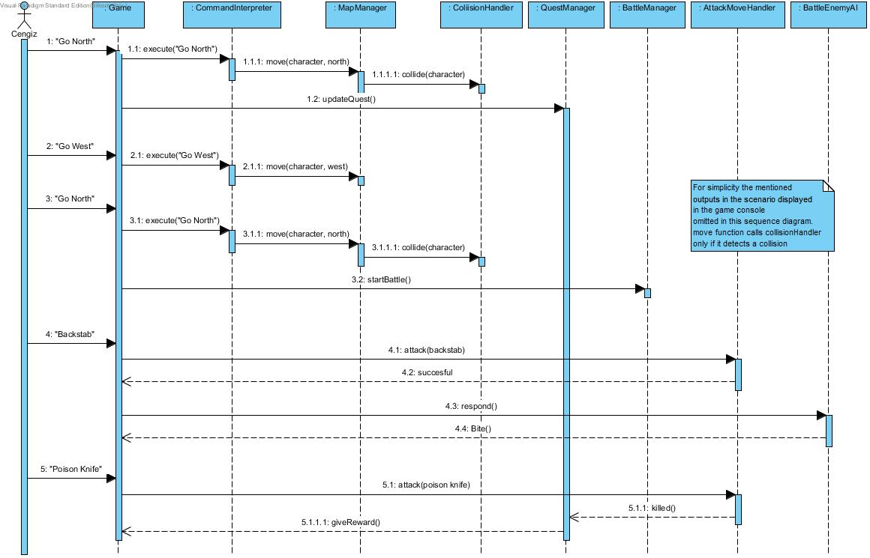
Figure 4.2.1: Sequence Diagram For Play Game Scenario

4.2.1.3 View Help
Scenario:Cengiz clicked the help option to view the help document. After reading it Cengiz learned that he can check how he is doing in the game so he typed “Statistics”. Game returned his Level, quest completeness percentage and score. After viewing them in the console he types “Return Game” to continue with the gameplay.
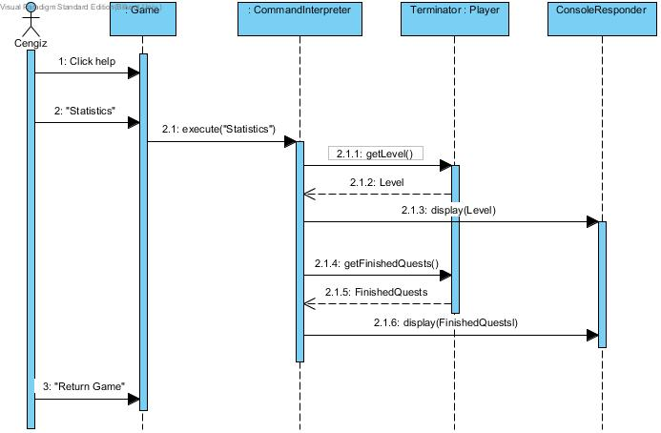
Figure 4.2.1: Sequence Diagram For View Help Scenario

4.2.1.4 Save Game
Scenario: After making some progress Cengiz decides to save his progress but to do so he must proceed to town center and type “save game” town center is located two blocks south and one block west. After reaching town center he types “save game” and console responds to him “save successful!”

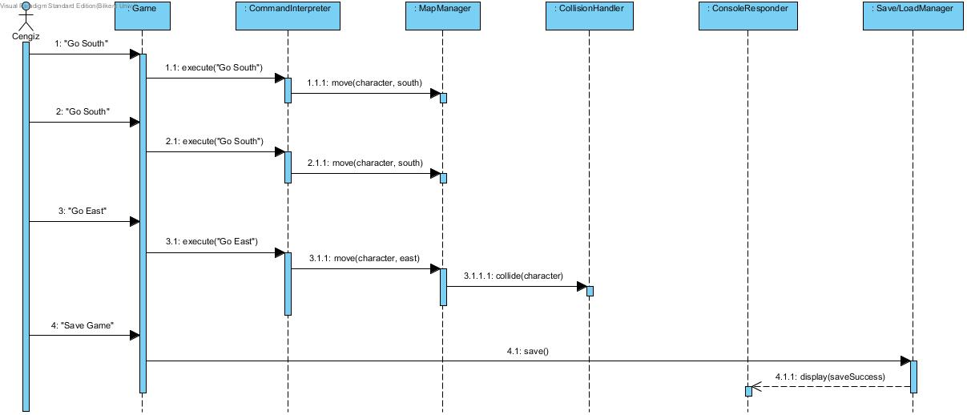

Figure 4.2.1: Sequence Diagram For Save Game Scenario

4.2.1.5 Load Game
Scenario: To continue with a former game session Cengiz selects load. His previous game is loaded and he continues to play from the save point of the game.

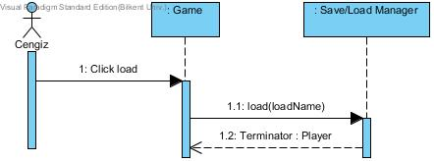
Figure 4.2.1: Sequence Diagram For Load Game Scenario

4.3 Object Model
The object model of Dread of Evil Wizard consists of 39 classes.
For Controller Objects, the game has:
File Manager: Responsible for saving the game progress and loading the game.
CommandInterpreter: Responsible for getting interpreting textual input from user and playing a role like a bridge between user and the game engine
Settings Manager:Used for adjusting the audio settings and the Difficulty Settings.
Quest Manager: Handles the quest progression of the game
Collision Handler: When the user roams through the map, he collides to an object. This object can be a block,NonPlayer Quest Giving Characters or Enemies. This Class controlls these collision and decides what to do according to the object player collided to.
Map Manager: Handles with player and enemies and the other entity objects which have a place on the map.
BattleManager: Controlls the battle engine. Creates a new map when the battle engaged with an enemy and handles with the battle.
Map: This is the map class that will contain the game objects like player,enemy etc.
Game Object: The objects of these class are the objects which occupy a place on the map.
Zone: Non-Battle map. Player roams through this map mostly
BattleMap: The map where battles Occur.
Character: Everything that can strike is a character. In other words, each character has Attributes listed in Overview part. They have attack points, they have health, stamina that will be used in battles. Each character has classes. Each classes has skills. Each skills has temporary effects. A skill might have damage values.
Player: The entity object that user controls. It is a character. Each Player has an inventory
TerrainCell: The grid cells of the Map. Contains a gameObject.
NPC: Entity object that gives Quest to the player

The following Class diagram represents the object model of the game.
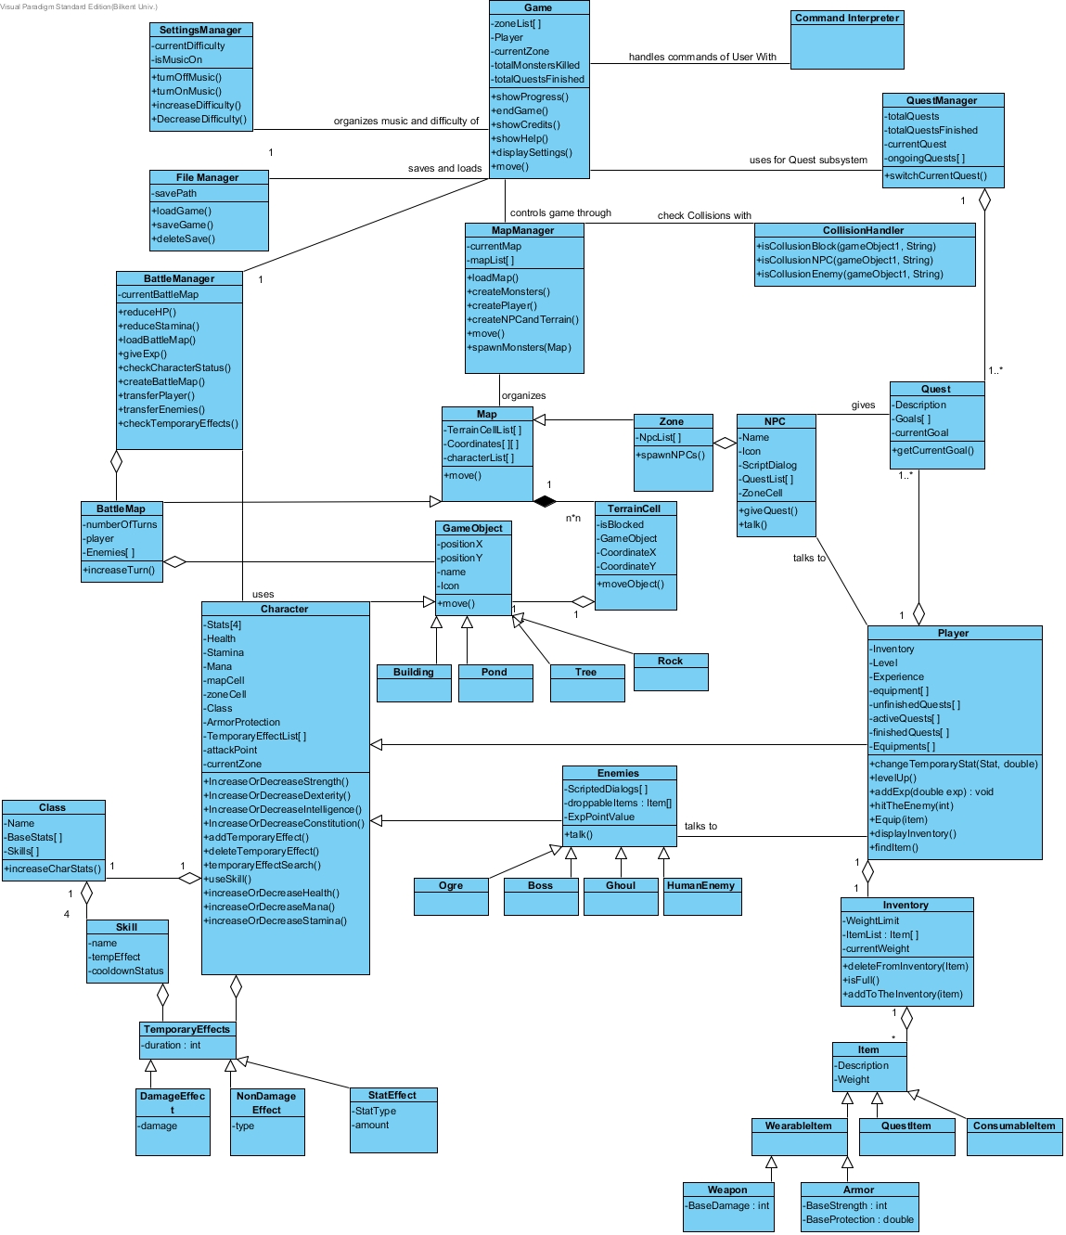
Figure 4.3.1 : Class Diagram for object model.

4.4 State Diagrams
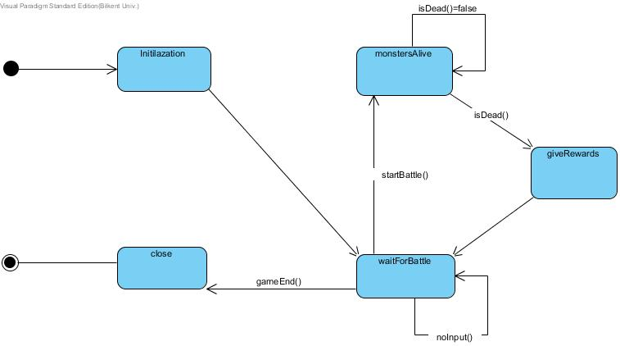
Figure 4.2 : State Diagram for Battle Managing.

A battle manager is initialized after game is started. Once player collides with a monster, it starts a battle. If monster is still alive, battle manager waits for either player or monster to be dead. Once any player is dead, Battle Manager gives Experience Point rewards to the Player. Once the game ends, Battle Manager is terminated as well

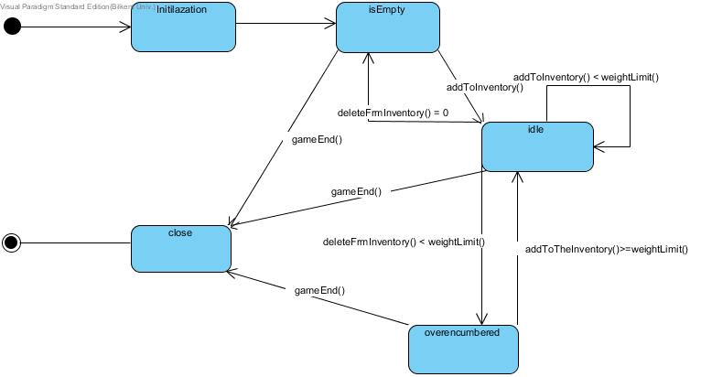
Figure 4.2.2: State Diagram for Inventory limit excession
If an item is added to the inventory and it exceeds limit, user needs to delete it from inventory to be able to idle again. Else, player will be overencumbered.

5 User Interface

5.1 Screen Mock-ups

5.1.1 Main Menu
When application begins to run, Player will see main menu screen. Main menu screen shows six options to Player which are play game, change settings, view credits, view own statistics, view help and exit game. (Figure 5.2.1)

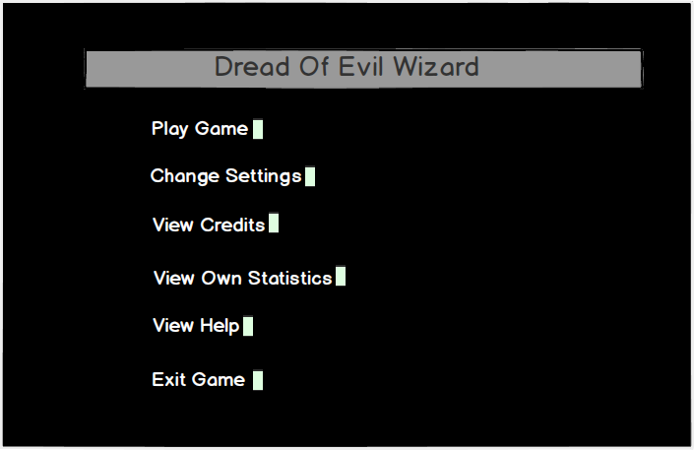
Figure 5.2.1 Screen shot of Main Menu

Play Game: If Player selects Play Game, player will select either New Game or Load Game. Figure 5.2.1.1 is a screen shot from Play Game Menu.Player can go to main menu by clicking on the Back button.
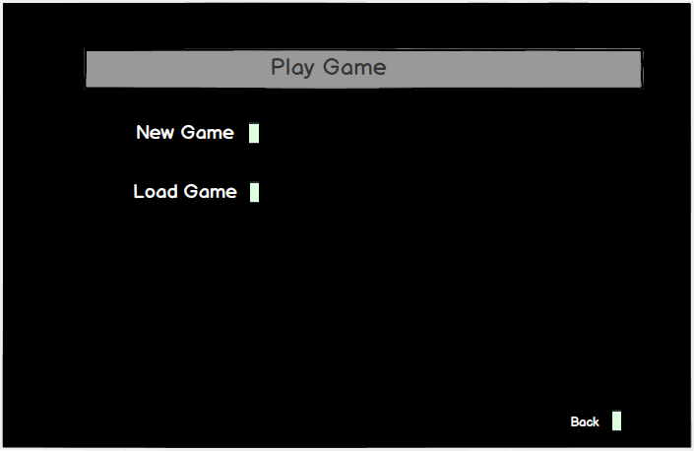
Figure 5.2.1.1 Screen shot of Play Game Menu
New Game: If Player selects New Game, then player will be able to select one of the three characters. Figure 5.2.1.2 is a screen shot from New Game Menu.Player can go to Play Game menu by clicking on the Back button.
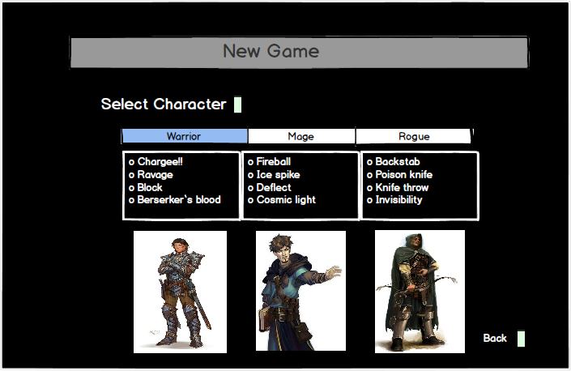
Figure 5.2.1.2 Screen shot of New Game Menu
Warrior: After player selects one of the characters based on their skills (for example warrior), he can start the game. Figure 5.2.1.3 is a screen shot from gameplay. The upper left space is for console messages, the upper right side is for multifunctional purposes such as map or visualization of war and the bottom space is text box to get commands from player.
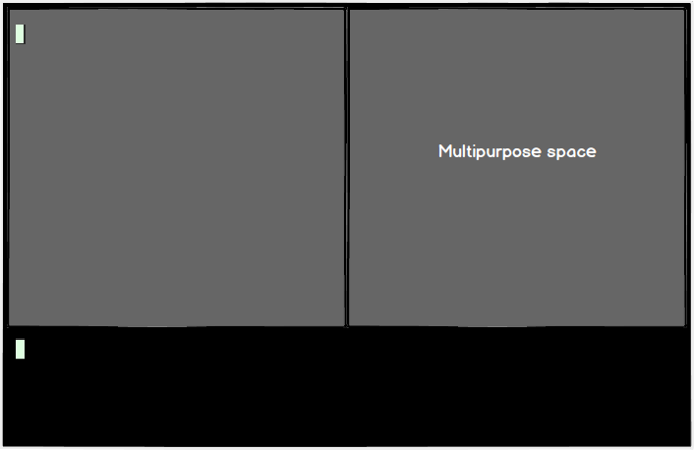
Figure 5.2.1.3 Screen shot of gameplay

Change Settings: When change settings button is pressed a list of options are shown on screen. These settings can be changed by Player manually. (Figure 5.2.1.4) Player can on/off game sounds and change the difficulty level of the game as easy or hard. The selected ones is shown in red color. Player can go to main menu by clicking on the Back butt 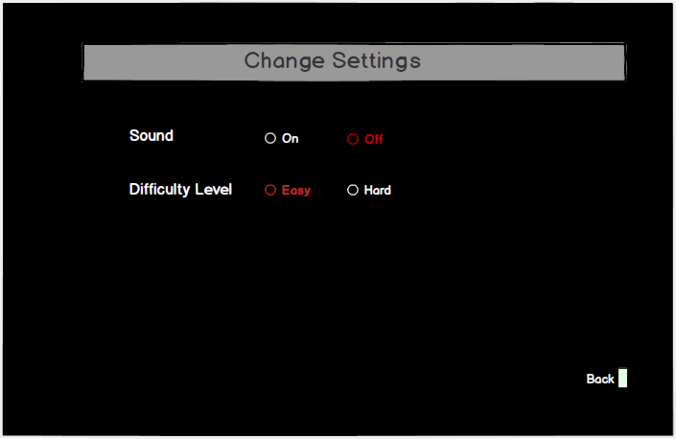
Figure 5.2.1.4 Screen shot of Change Settings
View Credits: When view credits button is pressed the developers of the game and the contact information will be shown on the screen. (Figure 5.2.1.5) Player can go to main menu by clicking on the Back button.
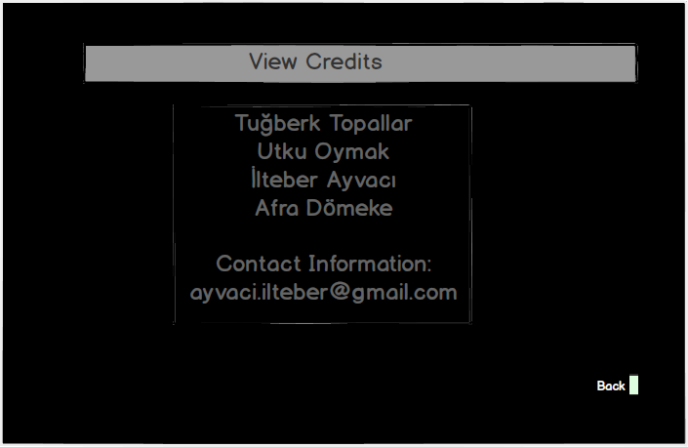
Figure 5.2.1.5Screen shot of View Credits
View Own Statistics: When View Own Statistics button is pressed, the percentage of completed content and the number of completed Quests, killed monsters, collected items will be shown.(Figure 5.2.1.6) Player can go to main menu by clicking on the Back button.

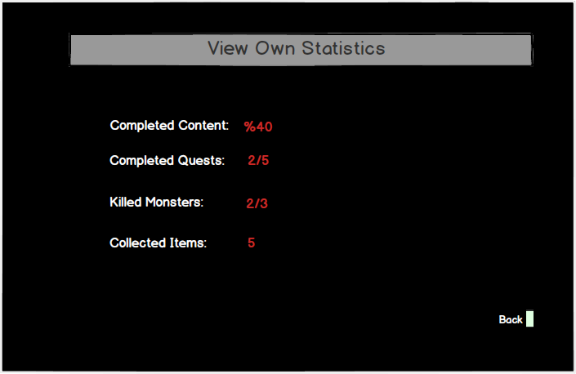
Figure 5.2.1.6 Screen shot of View Own Statistics

View Help: When the player selects View Help button System displays the help guide which contains information about game dynamics,monsters,and quests that is prepared by developer team. (Figure 5.2.1.7) Player can go to main menu by clicking on the Back button.
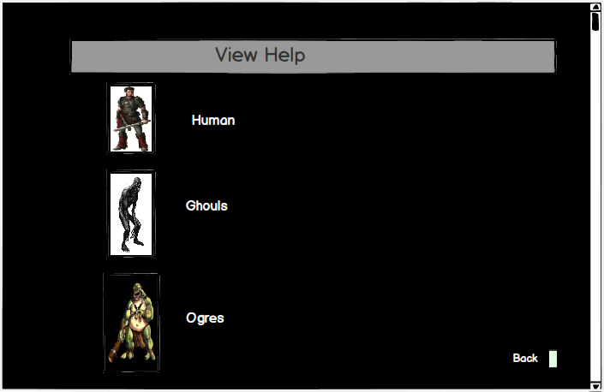
Figure 5.2.1.7 Screen shot of View Help Menu
Ogres: When the player wants to get information of the objects on the View Help Menu, he can click on it and the further information will be supplied about the selected item. (For example Ogres is selected in this particular example (Figure 5.2.1.8))Player can go to main menu by clicking on the Back button.
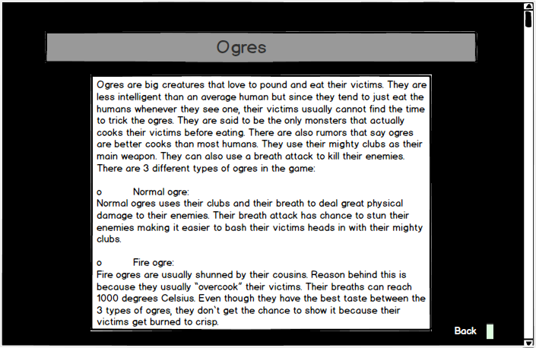Figure 5.2.1.8 Screen shot of Help menu of Ogres

https://s-media-cache-ak0.pinimg.com/236x/71/8b/12/718b129ff0f1b65cd1b0587f25e6d7e5.jpg)
(http://s.hswstatic.com/gif/stufftoblowyourmind-23-2014-06-HorridGhoul.jpg)
(http://www.algadon.com/images/monsters/ogre.png)

